

John Karuitha

P.O. Box 1957-10101,

Karatina, Kenya.

24 March 2022

Dear Sir/Madam

**Re: Invitation to Join the Wits African Centre for the Study of the United States as Research Associate**

I write to formally invite you to join the University the Witwatersrand’s African Centre for the Study of the United States (Wits ACSUS) as a Research Associate.

The Wits ACSUS was established in March 2018 with the mission of innovating and sustaining new ways of understanding the US, relevant to Africa and Africans through research, teaching, outreach, exchanges, public engagements, and publishing. We believe your wealth of experience and expertise will help achieve this mission, one that is critical for the African continent at pragmatic and scholarly levels.

We look to work with you on research and publication projects in the broad field of Africa-US politics. The subfields, themes and topics for collaboration will include but not be limited to governance, foreign policy, geopolitics, diplomacy, digital policies, digital humanities, democracy and human rights, political economy, electioneering, among others. Across the Africa-US politics field and its subfields, we shall work together on our existing projects, themes, and topics as well as those that you may suggest during your affiliation with the Centre. We shall work together in identifying publication platforms and your published work will cite your affiliation to Wits ACSUS as a Research Associate. We shall collectively work together creating a new body of knowledge forged in rigorous theoretical and methodological approaches.

Besides research and publication, we shall call on you to serve as a speaker and/or moderator during our events, as an advisor on the initiatives we undertake and as an advocate and supporter on issues around Africa-US engagements. Working with the Wits ACSUS staff and fellow research associates, you will help us identify historical and contemporary issues regarding Africa-US engagements.

Wits ACSUS will make every effort to provide support to you including support from our staff members, linkages within Wits University and sister universities across the continent and in the US, linkage to our partners including governmental and non-governmental and private sector. We shall offer monetary support such as honorarium and stipends especially with regards to funded projects. On successful fundraising, we shall also offer resources for fieldwork. We shall work together on fundraising for some of the initiatives you will be involved in.

In response to this offer, kindly indicate the specific research and publication projects you would be involved in. Also, kindly send us a short bio of 300 words or less and a high-resolution head shot picture. These will be uploaded on our website.

We look forward to pursuing the mission of shaping intellectual discourse and deepening the understanding of the US as a nation, society, and global power, from an Afrocentric standpoint.

Kindly see the attached ACSUS profile and access further information on our website: <https://africa-usforum.africa/>.

Sincerely

 John Karuitha

Dr Bob Wekesa 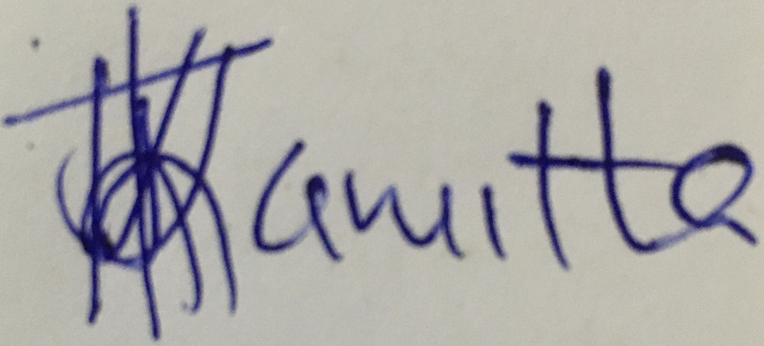Signed:

Deputy Director Date: March 30, 2021

African Centre for the Study of the US

University of the Witwatersrand

CC

Prof Gilbert Khadiagala

Director

African Centre for the Study of the US

University of the Witwatersrand